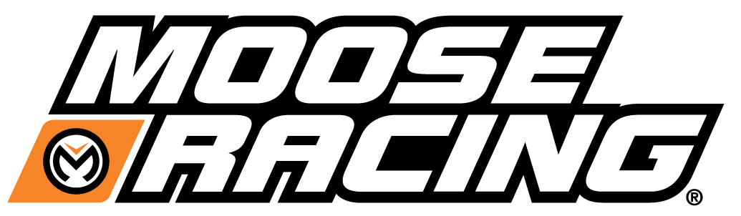
Presents
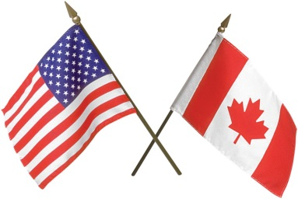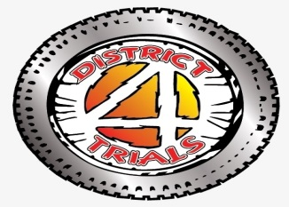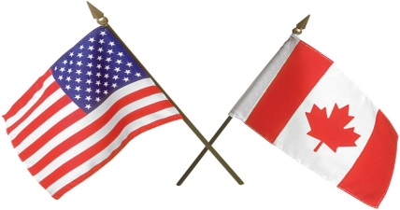
CAN AM Challenge
Motorcycle Trials Competition
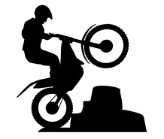 Saturday May 19th / Sunday May 20th 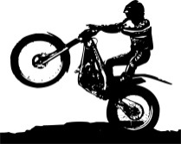
Schedule Sign in 10:30 Riders Meeting 11:45
Event Starts at NOON both Days
Saturday May 19th Event Sunday May 20Th Event
AMA License NOT Req’d AMA License Req’d
GATE Trial NATC Rules and
SELF CHECKING CHECKERS
FUN EVENT NY State D4 Championship
SPECTATORS ARE ALWAYS FREE AT D4 EVENTS Free Primitive Camping * Free Bike Wash * Prize Tables
******* Event Location 1100 White Hill Road #2 Alma NY 14895 *******
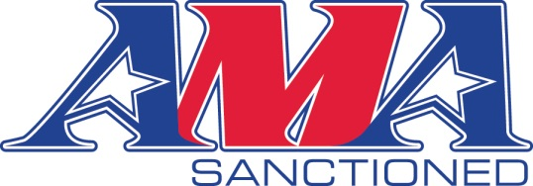
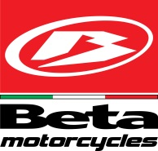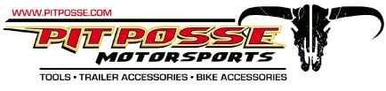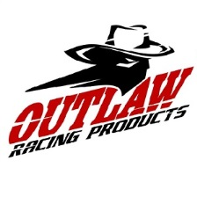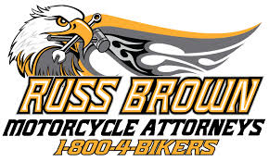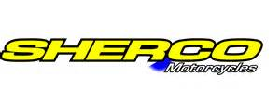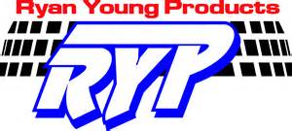

Event Contacts: Mike Thomson mike357@live.ca OR Rich Freer trialnut@hotmail.com
www.district4trials.com OR facebook district 4 trials committee

