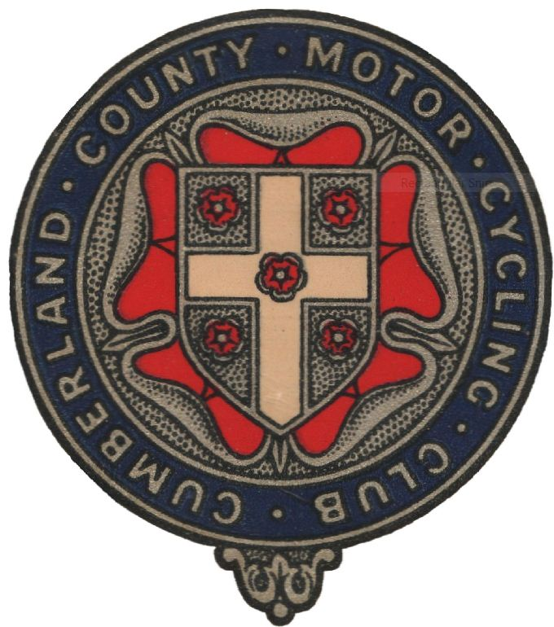
Cumberland County Motor Cycle Club Ltd
Northern Classic Experts
Sunday 13th August 2017 10:30am

The club will hold an Open Trial for appropriate solo machines only, held under the National Sporting Code rules of the ACU, the Standing Regulations for trials, and any final instructions which may be issued up until the start of the trial. Marking method will be TSR22B (no stop).

Course: The trial will be of a sporting nature with 2 laps of 20 sections with 2 routes, to be based at Thorlieshope Farm, Newcastleton TD9 0SW .(Signed from the B6357 approx 6m. N of Newcastleton). Start 10:30am

Entry Fees: Complete the form below and send with £20 fee (cheques payable to CCMCC) to:
Roger Kenyon, 11 Woolacombe Close, Warrington, Cheshire, WA4 2RU. (include SAE for a hard copy of results)

----------------------------------------------------------------------------------------------------------------------------
Rider
No.

Surname ____________________________ First Name _____________________

Address ___________________________________________________________________________

___________________________________Post Code_____________Phone_____________________

Club________________________________________ Affiliated Membership No. ________________

D.o B (if under 18) _________________ Machine & Capacity ________________________________

Email address_______________________________________________________________________

Route entered (tick) | Expert | Clubman

Class (tick) | A/C Monoshock | H. Spanish | Twinshock | Britshock/Pre 72

Entry declaration
I/we the undersigned apply to enter the event described above and in consideration thereof:
- I/we hereby declare that I/we have had the opportunity to read and that we understand the National Sporting Code of the ACU, the ACU Standing Regulations, such supplementary regulations as have or may be issued for the event, and agree to be bound by them.
- I/we further declare that I am/we are physically and mentally it to take part in the event and that I/we are competent to do so.
- I/we confirm that I/we understand the nature and type of event we are entering and its inherent risks and agree to accept the same notwithstanding that such risks may involve negligence on the part of the organisers or officials.
- I/we confirm that the machine(s) as described which I/we compete on shall be suitable and proper for the purpose.
- I/we confirm that I/we are eligible to compete on the machine(s) for which I/we have entered.
- I/we agree that I am/we are required to register our arrival by ‘signing on’ at the designated place prior to commencement of my/our practice or first competition, whichever occurs first.
- I/we confirm that I/we are not suspended or my/our ACU licence has not been suspended/withdrawn from any ACU competition.

Acknowledgement of the risks of motor sport
I/we understand that by taking part in this event I/we are exposed to a risk of death, becoming permanently disabled or suffering some other serious injury, and I/we acknowledge that even in the event that negligence on the part of the ACU, the promoter, the organising club, the venue owner, or any individual carrying out duties on their behalf were to be a contributory cause of any serious injury I/we may suffer, the dominant cause of any serious injury will always be my/our voluntary decision to take part in a high risk activity.

I/we have read the above and acknowledge that my/our participation in motor sport is entirely at my/our own risk.

Rider’s Signature ____________________________________________________ D.o.B. if under 18____________________

# For riders under 18 years of age – I accept the above conditions of entry to this event and give my approval:

Signature of parent or person with parental responsibility_______________________________________________

Riders under the age of 18 who cannot produce a valid ACU Competition Licence/Trials Registration must also complete a ‘Parental Agreement form (single event) in addition to this entry form.

