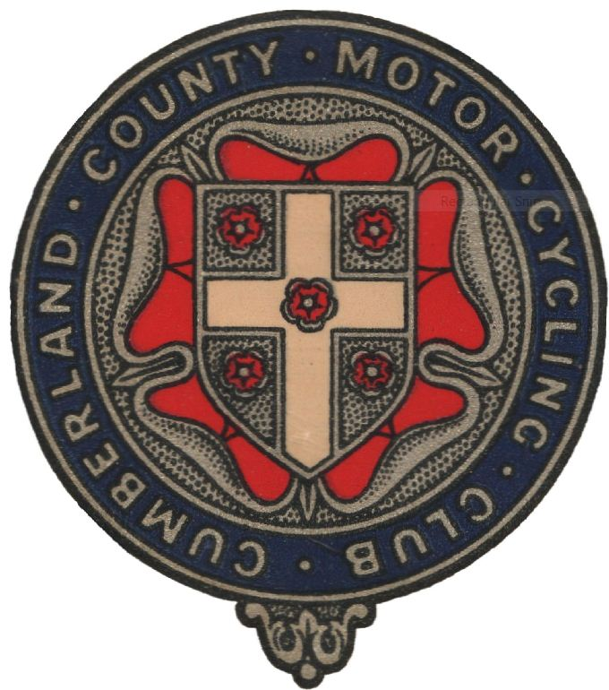
Cumberland County Motor Cycle Club Ltd

Northern Classic Experts
Sunday 13th August 2017

Venue: Thorlieshope Farm, Newcastleton TD9 0SW.
(Signed from the B6357 approx 6 miles N of Newcastleton)

Start Time:10:30am

Format: Clubmen - 2 laps x 20 Sections– Experts - 2 laps x 22 Sections. All Off Road !!!

Classes: A/C Mono, Historic Spanish, Twinshock, Britshock Pre ’72.

Marking: TRS 22B No Stop Permitted.

Entry limit: 120 riders with entries closing on Saturday 5th August.

Entries: £20. Please send to: Roger Kenyon
11 Woolacombe Close
Warrington
Cheshire
WA4 2RU.

Make cheques payable to CCMCC.

Results: Posted on club website and Trials Central, if you require a copy please send a SAE.

Fun Charity Practice Trial
Saturday 12th August 2:00 pm

Catering: Van on site both days

Camping: Available at the Riverside in Newcastleton for a small charity donation.
No camping at the Start Area!!

Further information: Paul Norman (COC), paulnorman09@hotmail.co.uk ,Tel:07801 447 616

Live Music at
The Grapes Hotel, Newcastleton
Saturday night!

