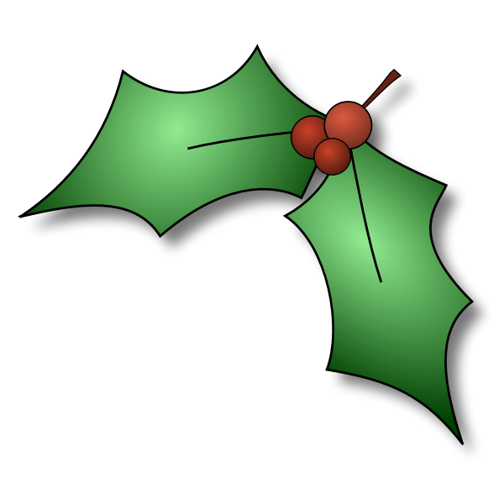
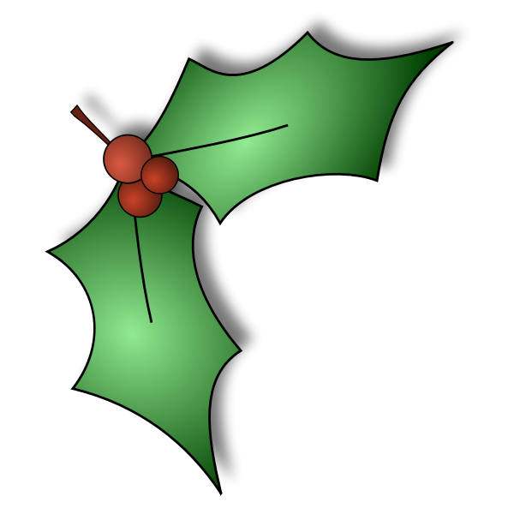
AJS & MATCHLESS POACHERS PRE 65 TRIALS

AFFILIATED TO THE CLASSIC SECTION OF THE AMCA
.
15th Covid19 (PRE-PAID Entry Form) Authorisation #38133 Email to sales@belton-4.co.uk

Christmas Charity Open Trial, 27th December 21.@ Smiths Farm Withcall Start Time 10:30 am

Entry Fee of £15 can be paid in advance upon receipt of confirmation email:
Please make a note of the new contact email address where entries should be forwarded
sales@belton-4.co.uk
Account Name: Poachers Pre 65 Trials Sort Code: 09-01-54 Account No: 07656081
using your name as a reference.
Your payment confirms acceptance to AMCA terms.

Please complete this form in full: Open to existing club members & guests
Closing date for entries 10:00am Friday 22nd December 2021

Name
Address
Postcode
Tel Number
Email Address
Machine Entered
Issued Riding Number | (N.A. new numbers issued for this event)

CLUBMAN | INTER | EXPERT

Pre-Unit Springer/Rigid |  | Pre-Unit Springer/Rigid |  | Pre-Unit Springer/Rigid
Unit Incl. Twins |  | Unit Incl. Twins |  | Unit Incl. Twins
Two Stroke |  | Two Stroke |  | Two Stroke
*Please X appropriate box*

We will email your confirmation in advance of the event.
No refunds will be given for DNS. If you can, please enter on-line. If you are unable to do so, entries and the correct cash payment will be accepted on the day. Please bring this completed form with you. Please follow all restrictions



